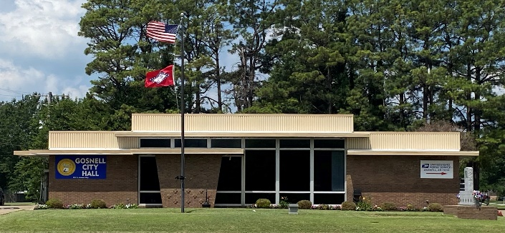

***[City of Gosnell](https://cityofgosnell.com/)* Gosnell, Arkansas *Est. 1968 http://cdn.phys.org/newman/gfx/news/hires/2015/efficientfun.jpg*** 

***city council Meeting***

**Date: August 12, 2025 Time: Tuesday 6:30 P.M.**

**Location: Gosnell – City Hall**

**AGENDA:**

1. Mayor Taylor calls meeting to order
2. Roll Call
3. Prayer:
4. Pledge of Allegiance
5. Approval of the June 10, 2025 council meeting minutes
6. Open floor to agenda items only
7. Derrek Bromley- Police
8. Resolution- Condemn Houses
9. Ordinance- Meeting time
10. Code Enforcement- Brian Grisham
11. Street Dept- Reba Spicer
12. Sewer Dept- Greg Robinson
13. Police- Chief Chris Hill “equipment”