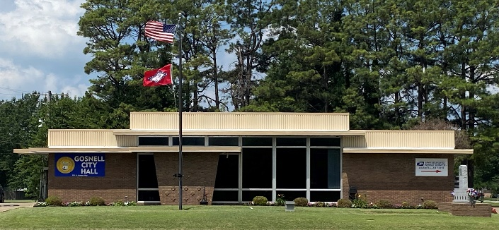
City of Gosnell Gosnell, Arkansas Est. 1968 http://cdn.phys.org/newman/gfx/news/hires/2015/efficientfun.jpg 

city council Meeting
Date: December 9, 2025 Time: Tuesday 5:30 P.M.
Location: Gosnell – City Hall

AGENDA:

- Mayor Taylor calls meeting to order
- Roll Call
- Prayer:
- Pledge of Allegiance
- Approval of the November 13, 2025 council meeting minutes
- Open floor to agenda items only
- Proposed 2026 Budget
- Ordinance No. Sewer Rate
- Code Enforcement- Brian Grisham
- Street Dept- Reba Spicer
- Sewer Dept- Greg Robinson
- Police- Chief Chris Lassley

