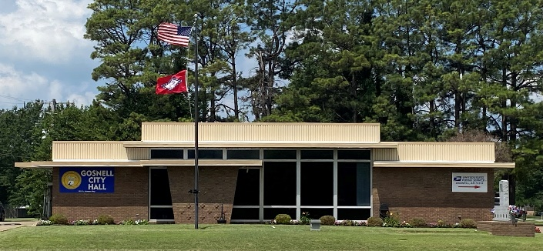
City of Gosnell Gosnell, Arkansas Est. 1968 http://cdn.phys.org/newman/gfx/news/hires/2015/efficientfun.jpg 

city council Meeting
Date: February 10, 2026 Time: Tuesday 5:30 P.M.
Location: Gosnell – City Hall

AGENDA:

- Mayor Taylor calls meeting to order
- Roll Call
- Prayer:
- Pledge of Allegiance
- Approval of the January 13, 2026 council meeting minutes
- Open floor to agenda items only
- Mayor Pro Tem
- Police- car cams
- List of boxes for disposal
- Resolution- Billing for out-of-town fires
- Committee Updates

