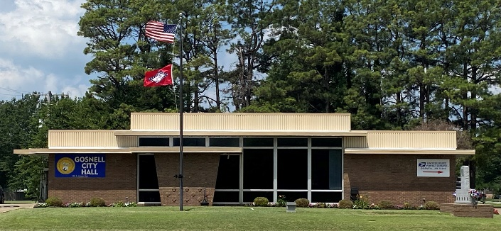
City of Gosnell Gosnell, Arkansas Est. 1968 http://cdn.phys.org/newman/gfx/news/hires/2015/efficientfun.jpg 

city council special Meeting
Date: April 27, 2026 Time: Monday 3:00 P.M.
Location: Gosnell – City Hall

AGENDA:

- Mayor Taylor calls meeting to order
- Roll Call
- Prayer:
- Pledge of Allegiance
- Resolution No. 252 amend 2025 budget
- Resolution No. 253 amend 2026 budget

