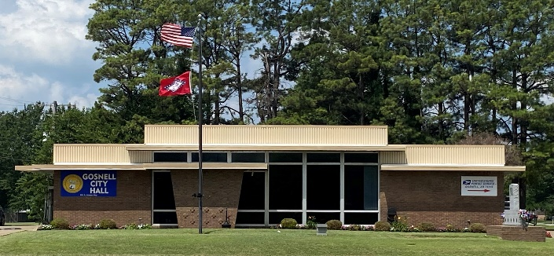
City of Gosnell Gosnell, Arkansas Est. 1968 http://cdn.phys.org/newman/gfx/news/hires/2015/efficientfun.jpg 

city council Meeting
Date: May 12, 2026 Time: Tuesday 5:30 P.M.
Location: Gosnell – City Hall

AGENDA:

- Mayor Taylor calls meeting to order
- Roll Call
- Prayer:
- Pledge of Allegiance
- Approval of April 14, 2026 council meeting minutes
- Approval of April 27, 2026 special meeting minutes
- Open floor to agenda items only
- RiverCity Hydraulics- rep garbage truck
- Committee Meeting Updates

