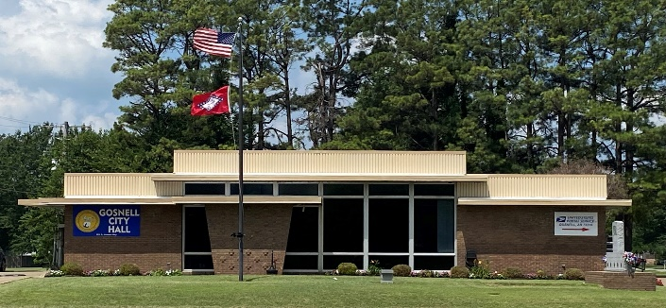
City of Gosnell Gosnell, Arkansas Est. 1968 http://cdn.phys.org/newman/gfx/news/hires/2015/efficientfun.jpg 

city council Meeting
Date: September 8, 2026 Time: Tuesday 5:30 P.M.
Location: Gosnell – City Hall

AGENDA:

- Mayor Taylor calls meeting to order
- Roll Call
- Prayer:
- Pledge of Allegiance
- Approval of the August 11, 2026 council meeting minutes
- Open floor to agenda items only
- Hunter Rounsvall- rename street
- Ordinance- modular homes in city limits
- Ordinance- feeding stray cats
- Resolution- Milage
- Committee Updates

