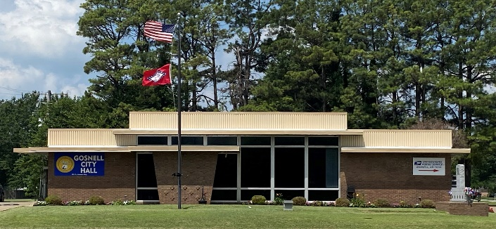
City of Gosnell Gosnell, Arkansas Est. 1968 http://cdn.phys.org/newman/gfx/news/hires/2015/efficientfun.jpg 

special meeting

city council Meeting
Date: September 18, 2026 Time: Friday 11:00 A.M.
Location: Gosnell – City Hall

AGENDA:

- Mayor Taylor calls meeting to order
- Roll Call
- Prayer:
- Pledge of Allegiance
- Ordinance: Axon body cameras

