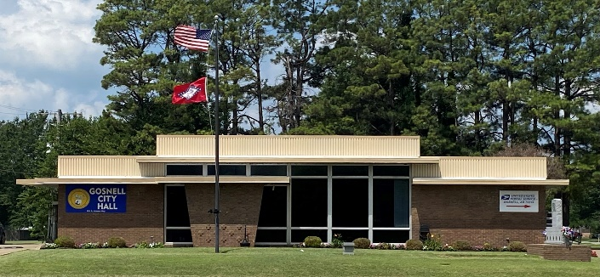
City of Gosnell Gosnell, Arkansas Est. 1968 http://cdn.phys.org/newman/gfx/news/hires/2015/efficientfun.jpg 

city council Meeting
Date: Tuesday October 13, 2026 Time: 5:30 P.M.
Location: Gosnell – City Hall
*TOWN HALL MEETING PRIOR AT 5:15 FOR RENAME OF GREGG LN TO ZANE LANE*
AGENDA:

- Mayor Taylor calls meeting to order
- Roll Call
- Prayer:
- Pledge of Allegiance
- Approval of September 8, 2026 council meeting minutes
- Approval of September 18, 2026 special meeting minutes
- Open Floor to agenda items only
- Ordinance: Zane Lane
- Ordinance: Stray Cats
- Draft of Updated handbook
- Committee Updates

